Business Requirement Document (BRD)
For
Credit Assistance to E-Commerce Exporters

Document Title | New Scheme Development – Credit Assistance to E-Commerce Exporters
Version | 1.0
Date | 11th May 2026
Prepared By (Infoneo) | Pinkey (BA)

Table of Content

1. Introduction 3
1.1 Purpose 3
1.2 Scope 3
2. System Overview 3
2.1 Fund and Docket Construct 4
3. Modules 5
3.1 New CG Module:- 5
3.3 For Valid Records 9
3.4 CG Fee Calculation 12
Guarantee Issuance Flow 12
3.5 Calculation based on GST 14
4. Reports 16
5. Search & View CG Module 16

Introduction

Purpose
This document outlines the functional requirements for the development of a new scheme under the SURGE platform for Credit Assistance to E-Commerce Exporters, including API integrations, guarantee processing, fee calculation, invoice generation, and payment workflows.

Scope
The system will:
- Integrate with EXIM Bank via APIs
- Process MLI and loan data
- Calculate guarantee fees
- Generate invoices with email alert given to MLIs
- Manage collections via API integration and penalties
- Issue guarantees post payment
- Sanction report MIS
- Search & View CG module for this scheme

System Overview

The system will function in a fully API-driven model, where:
- Data received from EXIM Bank is treated as final and approved
- No Maker-Checker workflow is required
- All validations, calculations, and processing will be automated. Direct estimate of invoice will be generated.
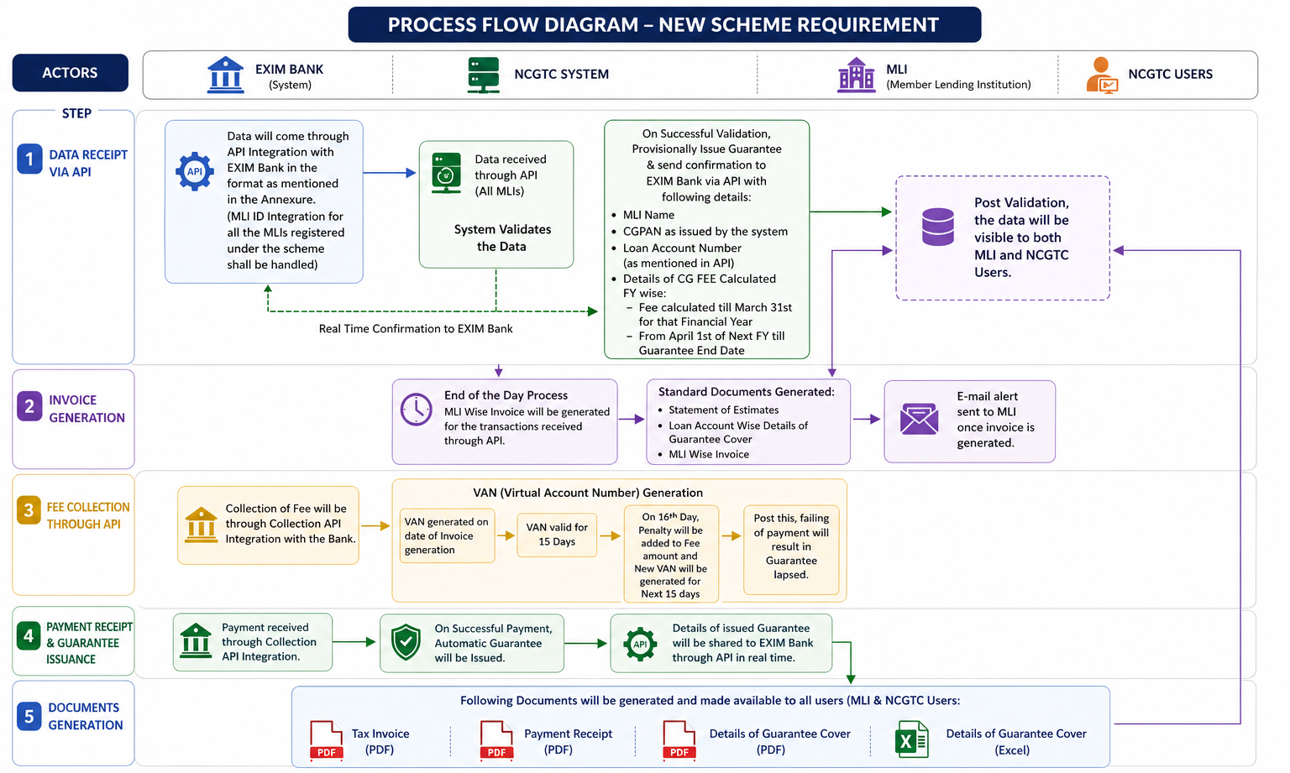

API Integrations Required:-
API Type | Description
New CG API | Receive fresh guarantee data from EXIM Bank
Enquiry API | EXIM Bank can pull data related to the MLI list
Collection API | To sent payment details to EXIM Bank via API

2.1 Fund and Docket Construct
Currently it is being envisaged that this scheme will have two docket. These dockets have codes – “Direct E-Commerce Credit Facility” and “Overseas Inventory E-Commerce Credit Facility” respectively as mentioned below:-
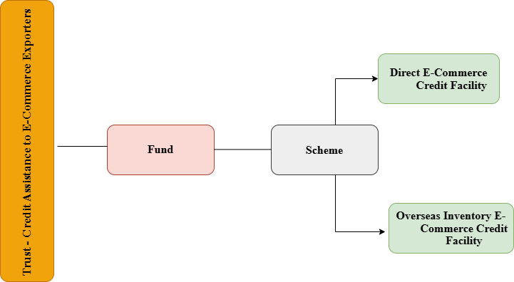

Dockets
Category Name | Docket Code
Direct E-Commerce Credit Facility | DEC
Overseas Inventory E-Commerce Credit Facility | OIE

3. Modules
3.1 New CG Module:-
EXIM Bank will sends bulk data via the New CG API and the system will processes it through record-by-record validation.
Below are the fields mentioned:-

Field Name | Details | Field Type | Mandatory/Optional
MLI Name | Name of Bank who has sanctioned the Facility | Alphanumeric | Mandatory
MLI ID | MLI ID as per NCGTC | Alphanumeric | Mandatory
Unit Name | Name of the exporter | Alphanumeric | Mandatory
Exporter ITPAN | PAN of the exporter | Alphanumeric | Mandatory
Importer Exporter Code (IEC) | Exporter’s (Importer Exporter Code) | 10-digit Alphanumeric | Mandatory
Udhyam Registration Number | 19 digit Udyam Registration Number (i.e. UDYAM-XX-00-0000000).E.G. UDYAM-GJ-21-0123456 | Number (Upto 19 digits) | Mandatory
Unique Identification Number (UIN) | UIN issued on DGFT portal to exporter | Alphanumeric | Mandatory
Email Id of Exporter | Official email ID of exporter | Alphanumeric following Standard Email Rules | Optional
Mobile No. of Exporter | 10-digit mobile number of exporter | Number (Upto 12 digits) | Mandatory
Chief Promoter Gender | Male/Female/Other | Text (List) | Mandatory
Religion of Chief Promoter | Religion of chief promoter | Text (List) | Mandatory
Caste Category of Chief Promoter | SC/ST/OBC/General/Other | Text (List) | Mandatory
Constitution Type | Proprietorship/Partnership/Company/LLP/ Other | Text (List) | Mandatory
Type of Entity | Micro/Small/Medium | Text (List) | Mandatory
Present – Address Line | Borrowers present address of residence – Room no. & Building | Alphnumeric | Mandatory
Present – City/Town/Village | Borrowers present address of residence – City/Town/Village | Alphnumeric | Mandatory
Present – District | Borrowers present address of residence – District | List – Available in surge Code | Mandatory
Present – State | Borrowers present address of residence – State | List – Available in surge Code | Mandatory
Present – Pin Code | Borrowers present address of residence – Pin Code | Number (Upto 6 digits) | Mandatory
Intervention Type | Direct E-Commerce Credit Facility /Overseas Inventory E-Commerce Credit Facility | List | Mandatory  (CG FEE will decided based on this)
Customer ID | Customer Id issued by the lending institution for the borrower | Alphanumeric | Mandatory
Loan Account Number (Unique within MLI) | Numeric / Alpha Numeric | TEXT | Mandatory
Sanction Amount (Check on PAN & Intervention Type) | The total loan amount sanctioned by MLI should be limited to Rs.50 lakhs for Direct E-Commerce Credit Facility and Rs. 5 cr for Overseas Inventory E-Commerce Credit Facility | Number With 2 Decimals | Mandatory
Sanction Date | Date of loan sanctioned by MLI as per scheme eligibility rules/guidance, from all the sanctions for this borrower. Sanction date >= scheme notification date, Sanction date <= system date, sanction date <= scheme close date  Sanction date cannot accept future date. | DD-MM-YYYY | Mandatory
Industry Nature | Copy the required value From Given List only | TEXT | Mandatory
Industry Sector | Copy the required value From Given List only | TEXT | Mandatory
Tenure of Loan | Number only in days (The maximum guarantee tenure shall be 365 days). | Number | Mandatory
Interest Rate | Interest Rate Charged By MLI’s | Number With 2 Decimals | Mandatory
Guarantee Amount | CG FEE to be calculated on this amount | Number With 2 Decimals | Mandatory
Guarantee Start Date | Will be provided by EXIM bank | DD-MM-YYYY | Mandatory  (Tenure for which fee will be calculated)
Guarantee End Date | Will be provided by EXIM bank | DD-MM-YYYY | Mandatory  (Tenure for which fee will be calculated)

Note, The Guarantee Start Date and Guarantee End Date will be the difference of 365 days. (SD-ED)

List Of Industry Nature and Industry Sector attached below:-

3.2 Real-Time Data Validation & Confirmation to EXIM Bank

Once our system will validate the Data, through Enquiry API EXIM bank can pull related to MLI list. The System will provide following data by provisionally issuing the Guarantee:-
- MLI Name
- CGPAN as issued by the system
- Loan Account Number as mentioned in the API
- Details of CG FEE Calculated FY wise

Note, collection of fee will be through collection API integration with EXIM Bank.
- Guarantee Issuance Post Payment:- Upon successful receipt and confirmation of payment through the integrated collection mechanism, the system shall automatically process the final issuance of the guarantee without any manual intervention.
- The system shall trigger an API response to EXIM Bank, sharing the confirmed guarantee details for their records and further processing.
- Post guarantee issuance, the system shall generate and make available the following documents to all relevant stakeholders (MLI and NCGTC users):
- Tax Invoice (End of the Day single bill generation MLI-wise for all transaction)
- Payment Receipt
- Guarantee Cover Details, including:- PDF format, Excel format
All documents shall be generated in accordance with the standard formats followed across existing schemes on the platform and shall be available for download through the system at MLI side & NCGTC side.

Data Validation Logic: -
The system will implement strict validation checks before processing any API data:-
- MLI ID must exist in the system.
- Guarantee Amount must satisfy: Guarantee Amount ≤ Sanction Amount
- Industry Sector must be mapped correctly with the selected Industry Nature. Mismatched combinations will be rejected.
- Guarantee fee will be calculated on the Guaranteed Amount i.e. Fee calculated till March 31st for that Financial Year and from April 1st of Next FY till Guarantee End Date as mentioned by the EXIM Bank. Applicable Rates mentioned below:-
- If Intervention type is Direct E-Commerce Credit Facility :- 0.5% per annum
- If Intervention type is Overseas Inventory E-Commerce Credit Facility:- 1% per annum
Post Validation the data will be visible to both MLI and NCGTC Users.

3.3 For Valid Records
- Guarantee Creation:-
Upon successful validation of records received via API, the system shall create a provisional guarantee for the respective loan account with CGPAN generation.
- CG Fee Calculation:-
The system shall compute the Credit Guarantee (CG) Fee based on the guaranteed amount and applicable rate, in accordance with the defined calculation methodology. ( Illustration mentioned in below sections)
- Invoice Estimate Generation & Notification:-
The system shall generate an Invoice Estimate at the end of the day for the transactions received through API and trigger an automated email notification to the respective MLI.
- The invoice shall clearly specify the payment due date, which will be 15 days from the date of invoice generation.
- If payment is not received within the initial 15- day period:
    - On the 16th day, a penalty amount shall be applied to the fee amount.
    - A new Virtual Account Number (VAN) shall be generated for the revised amount.
    - An additional 15-day payment window shall be provided from the date of penalty application.
- In case the payment is still not received within the extended timeline, the system shall automatically mark the guarantee as “Lapsed”.

Illustration: Penalty Calculation on Guarantee Fee
Scenario:
- Invoice Date: 01 June 2025
- Guarantee Fee Amount: 10,000
- Payment Due Date (15 days): 16 June 2025

Case 1: Payment within Due Date
- If payment is made on or before 16 June 2025
- Amount Payable: 10,000
- Status: Active
Case 2: Payment after Due Date (Penalty Applicable)
If payment is not received by 16 June 2025:
  - On 17 June 2025 (16th day), penalty is applied
Penalty Calculation: ( Exact penalty Rate to be confirmed from Avani mam)
- Penalty Rate: 2% of Guarantee Fee
- Penalty Amount: 200 (2% of 10,000)

Revised Amount:
- Total Payable = 10,000 + 200 = 10,200
System Actions:
- New VAN generated for 10,200.
- New Payment Due Date: 01 July 2025 (15 days from penalty date).
Case 3: Non-Payment after Extended Timeline
If payment is not received by 01 July 2025:
- Guarantee Status: Marked as “Lapsed” by the system
Particulars | Amount (INR)
Guarantee Fee | 10,000
Penalty (2%) | 200
Total Payable | 10,200

3.4 CG Fee Calculation

Guarantee Issuance Flow
- Data received from EXIM
- Validation checks executed
- Eligibility determined
- Guarantee calculated
- Guarantee issued via API

Guarantee Coverage Logic
- Guarantee fee will be calculated on the Guaranteed Amount i.e. Fee calculated till March 31st for that Financial Year and from April 1st of Next FY till Guarantee End Date as mentioned by the EXIM Bank

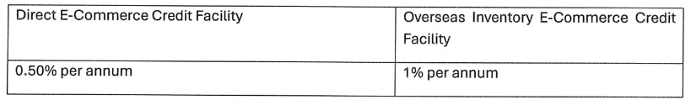

Illustration: CG Fee Calculation (Financial Year-wise Split)

Assumptions for Example:- If Intervention Type = Direct E-Commerce Credit Facility (0.50%)
Parameter | Value
Guarantee Start Date | 27-Apr-26
Guarantee End Date | 10-Aug-27
Guaranteed Amount | ₹ 10,00,000
Intervention Type | Direct E-Commerce Credit Facility
Applicable Rate | 0.5% per annum

Step 1: Identify Financial Year Split
The fee will be calculated across two financial years:
FY 2026–27
- Period: 27 April 2026 to 31 March 2027
- Number of days: 339 days
FY 2027–28
- Period: 1 April 2027 to 10 August 2027
- Number of days: 132 days

Step 2: Apply Fee Calculation Formula
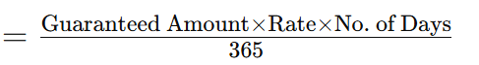

Step 3: Calculate Fee for Each Financial Year

FY 2026–27 Calculation
- Fee = (10,00,000 × 0.5% × 339) / 365
- Fee = (10,00,000 × 0.005 × 339) / 365
- Fee = ₹4,643 (approx.)

FY 2027–28 Calculation

- Fee = (10,00,000 × 0.5% × 132) / 365
- Fee = (10,00,000 × 0.005 × 132) / 365
- Fee = ₹1,808 (approx.)

Step 4: Total CG Fee

Financial Year | Fee Amount
FY 2026–27 | ₹ 4,643
FY 2027–28 | ₹ 1,808
Total Fee | ₹ 6,451

Illustration for Second Case
If Intervention Type = Overseas Inventory E-Commerce Credit Facility (1%)
- The same calculation logic will apply
- Only the rate changes from 0.5% → 1%
Revised Fee

Financial Year | Fee Amount
FY 2026–27 | ₹ 9,286
FY 2027–28 | ₹ 3,616
Total Fee | ₹ 12,902

3.5 Calculation based on GST
As per GST policy, tax on GST is primarily based on MLI’s Headquarters’ location i.e. the state in which MLI is primarily based. NCGTC’s state of operations is decided as Maharashtra state.

If the state of MLI operation is Maharashtra:
Then as per GST policy, CGST and SGST will be applicable in the tax calculation.
The formula is as below:
Tax on Guarantee Fee = (Credit Guarantee Fee * CGST Rate Defined in SURGE) + (Credit Guarantee Fee * SGST Rate Defined in SURGE)

CAECE Scheme Parameters
Guarantee Cover (%) | 75%
Annual Guarantee Fee (%) | 0.50%
Maximum Limit to Guarantee Issuance Allowed (INR) | 1,50,000.00
Minimum Limit to Guarantee Issuance Allowed (INR) | 5000.00
Sanctioned Loan Amount | 1,00,000.00
CGST | 9%
SGST | 9%
IGST | 18%
In case of this scenario, Guarantee Fee calculation will be based on Guarantee Loan Amount.
Guarantee Loan Amount | 1,00,000.00
Thus the Guarantee Fee = 100,000 * (0.5%)
Which equals to INR 500/-
Taxation on INR 500/- is determined as below:
- SGST Tax on this Fee @9% is 500*9% = INR 45/-
- CGST Tax on this Fee @9% is 500*9% = INR 45 /-
Total Tax is summation of CGST and SGST = 45 + 45 = INR 90/-

If the state of MLI operation is Not Maharashtra:
Then as per GST policy, IGST will be applicable in the tax calculation.
The formula is as below:
Tax on Guarantee Fee = (Credit Guarantee Fee * IGST Rate Defined in SURGE)
CAECE Scheme Parameters
Guarantee Cover (%) | 75%
Annual Guarantee Fee (%) | 0.50%
Maximum Limit to Guarantee Issuance Allowed (INR) | 1,50,000.00
Minimum Limit to Guarantee Issuance Allowed (INR) | 5000.00
Sanctioned Loan Amount | 1,00,000.00
CGST | 9%
SGST | 9%
IGST | 18%

Guarantee Loan Amount | 1,00,000.00

Thus, in case of this scenario, Guarantee Fee calculation will be based on Guarantee Loan Amount.
Thus the Guarantee Fee = 100,000 * (0.5%)
Which equals to INR 500/-
Taxation on INR 500/- is determined as below:
- IGST Tax on this Fee @18% is 500*18% = INR 90/-
Total Tax, IGST = INR 90/-

API Details:
- MLI Enquiry API
  - There will be an enquiry API from EXIM Bank (without any input parameters), which may be referred to as the MLI Enquiry API.
  - The API response should provide the list of registered MLIs under the CAECE Scheme in the SURGE system, including:
    - MLI ID
    - MLI Name

- New CG (Guarantee Issuance) API
  - There will be another API for New CG (Guarantee Issuance), through which EXIM Bank will share the finalized guarantee application details.
  - The API should return either:
    - Success Response containing:
      - CGPAN
      - CG Fee Amount
      - CGST
      - SGST
      - IGST
      - Total GST
      - Total CG Fee Amount
    - Failure Response containing:
      - Appropriate Error Message

4. Reports
Sanction reports required at MLI side & NCGTC side in the below-mentioned template format with download functionality:-


5. Search & View CG Module
In the View CG / Search CG module, the user is currently required to select parameters such as MLI Name, Scheme, and Loan Account Number / CGPAN / Customer ID. Based on the selected criteria, the system displays detailed information for the respective loan account under the Master and Transaction tabs on the View Details page at MLI Creator/Approver & NCGTC Creator/Approver side.
Master Tab :-
- Unit Name
- Exporter ITPAN
- Importer Exporter Code (IEC)
- Udhyam Registration Number
- Unique Identification Number (UIN)
- Chief Promoter Gender
- Religion of Chief Promoter
- Caste Category of Chief Promoter
- Constitution Type
- Type of Entity
- Present – District
- Present – State
- Intervention Type
- Customer ID
- Industry Nature
- Industry Sector

Transaction Tab
- Loan Account Number
- Sanction Amount
- Sanction Date
- Tenure of Loan
- Interest Rate
- Guarantee Amount
- Guarantee Start Date
- Guarantee End Date
- Payment Date
- CG fee
- Total Fee
- Tax

